# Exercise: Computer Systems and Software – Trello

Problems for exercises and homework for the ["Software Technologies" course @ Software University.](https://softuni.bg/trainings/4383/software-technologies-january-2024)

## Trello Web App

Keep in mind that some of the steps might be a bit different. **Atlassian regularly changes something in all of their apps**. We assume that if you are considering exploring the QA profession, you have the basic skills to download, install, register and find workarounds in various software programs, without any difficulties.

**1.** **Navigate** to [**https://trello.com/**](https://trello.com/) and click on the "**Get Trello for free**" button.

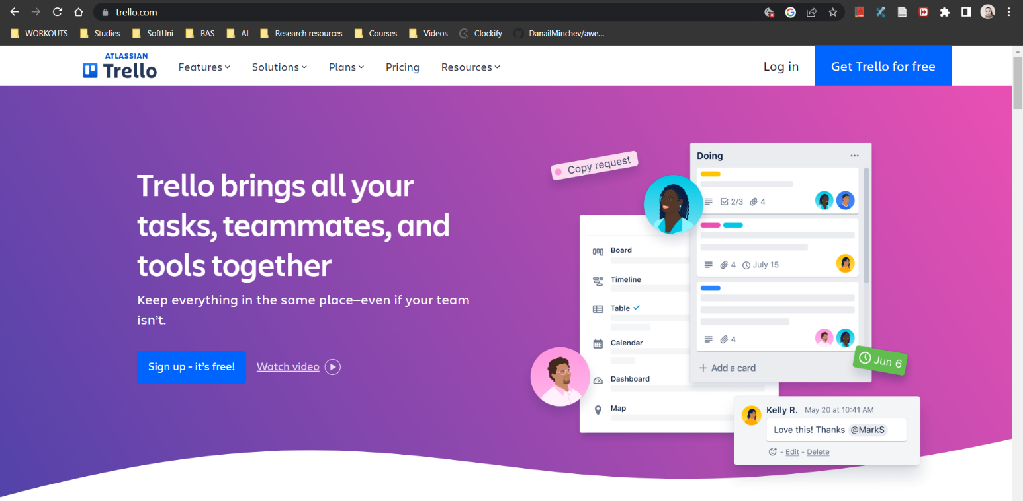

**2.** On the next page, you have **many different options to sign up / sign in**, so choose the one that fits you best.

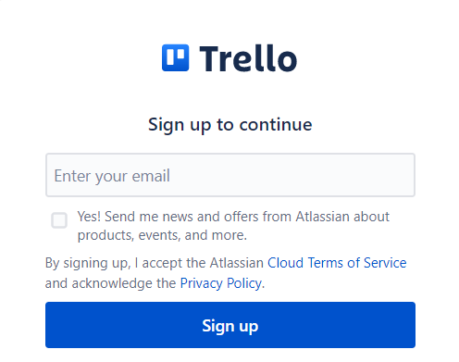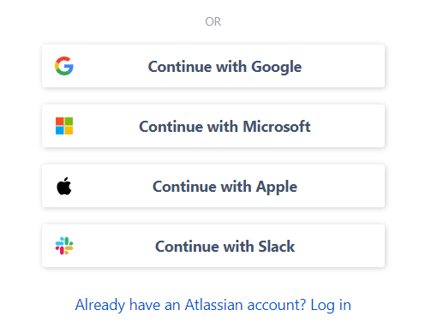

**3.** You will see a **"Welcome to Trello" message** and a prompt to **create and name your new Workspace**. Add teammates if you like. And **click "Create your Workspace".**

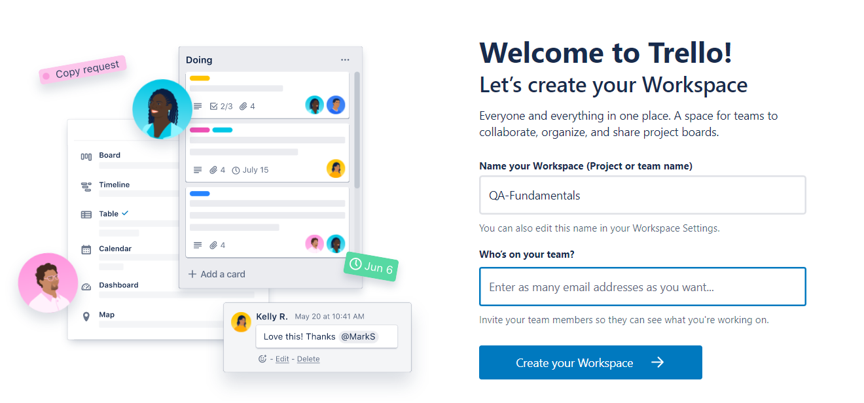

**4.** You don't need a premium plan. **Click "Skip".**

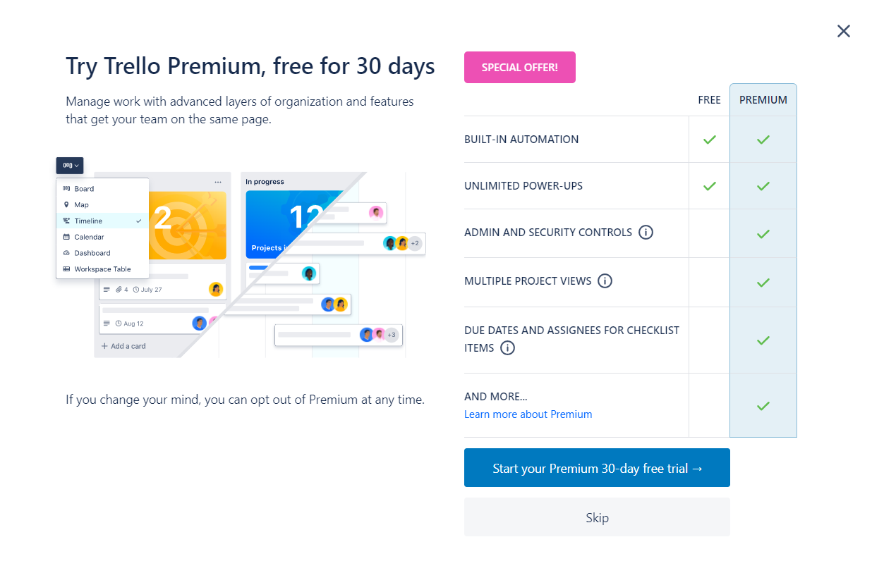

**5. You are now taken to your project**, which in our case **is called "QA-Fundamentals"** and has one **"Untitled board".** You can **change the name** of the board, by **clicking directly on it**.

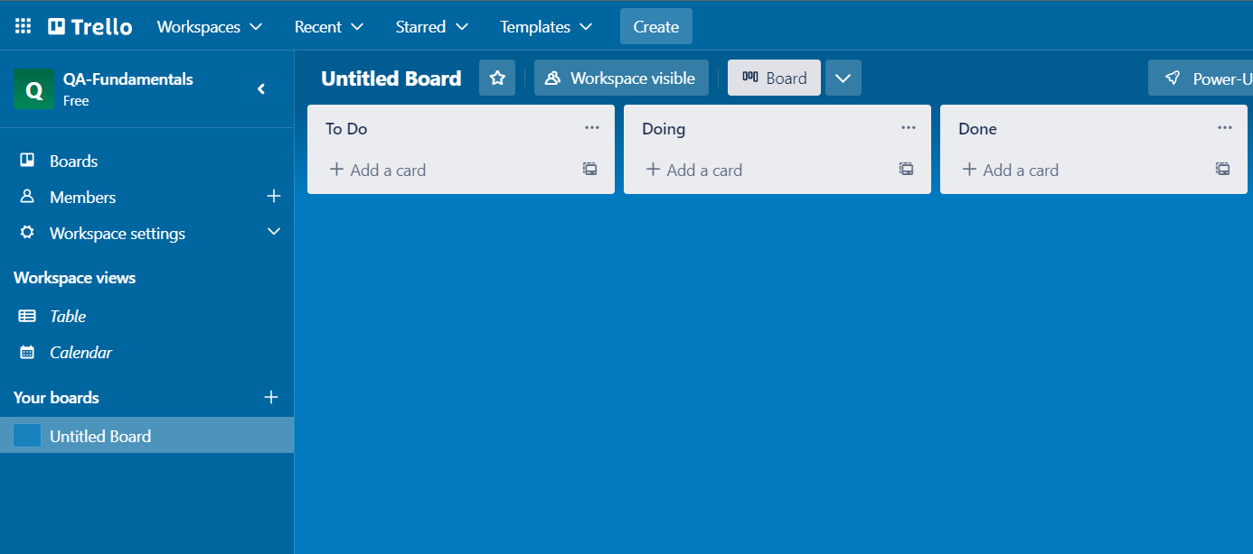

**6.** As you can see, **by default** there are **three lists** on your board, called **"To Do", "Doing"** and **"Done"**.You can add more lists, depending on the project you are working on and its needs. So, let's create another list, called **"On Hold"** because everybody has some tasks that are postponed. 😉 Click on the "Add another list" button.

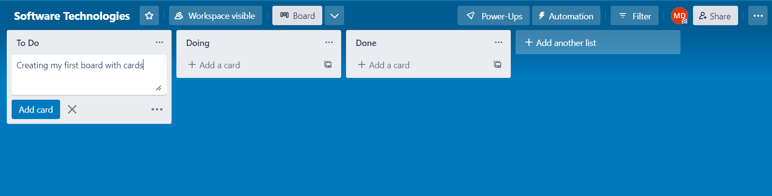

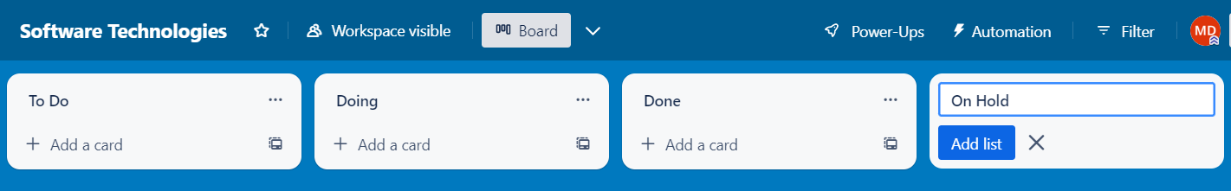

**7.** Now let's **create our first card**. By "card" Trello means task. So, **we click "+ Add a card" on the "To Do" board** and you will be prompted to enter a name for this card. We're naming the card **"Download and install Trello Desktop!"** because this is exactly what we're going to do later.

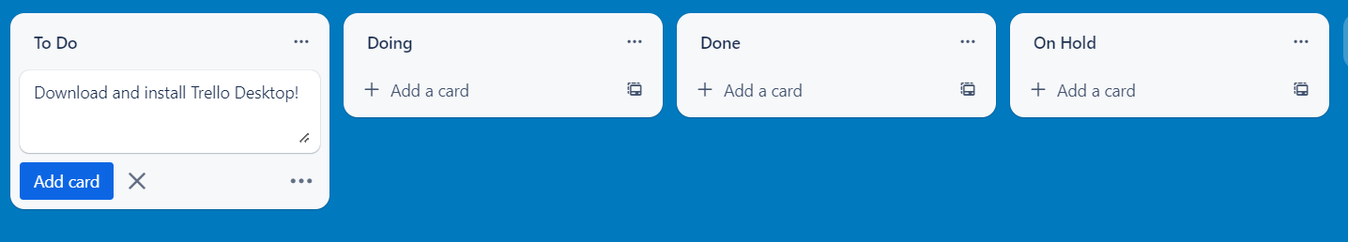

**8.** At this point, if you hit Enter or the blue button "Add card", you'll be given the opportunity to create another card, so let's do it. **Create another card and name it "Homework".**

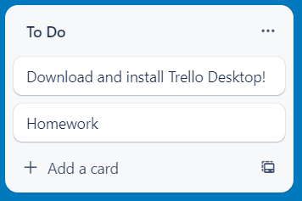

**9.** Now, **hover** over the "Homework" title and when a **small pencil appears, click on it.**



**10.** A menu with a few options will appear. **Choose "Move".**

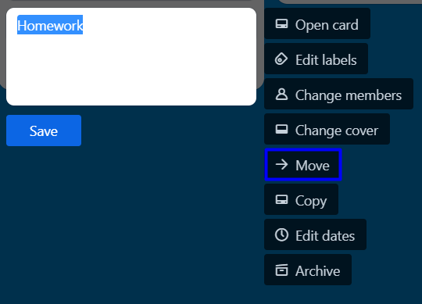

**11.** And then move the card **from the "To Do" to the "On Hold" list**.

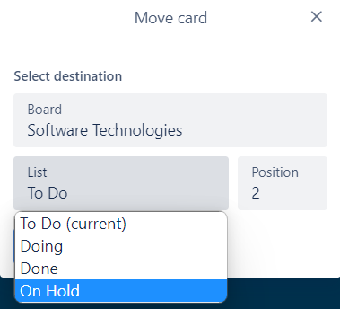

**12.** So now you have one card in the "To Do" and one card in the "On Hold" list. Open the **"Download and install Trello Desktop!" card**. You can do that by clicking "Open card" through the menu or by clicking directly on the title (not the little pencil, directly on the title).

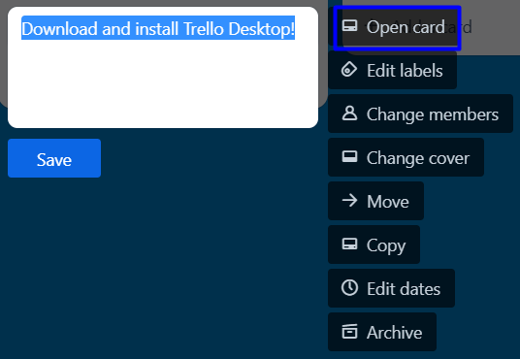

**13.** And this is your **card's details**. You can edit it whichever way you like. You can add members, labels, checklists, dates, attachments, etc. For now, we will just **add a comment "I'll download Trello Desktop right about now!"** in the comment section and then move the card to the "Doing" list.

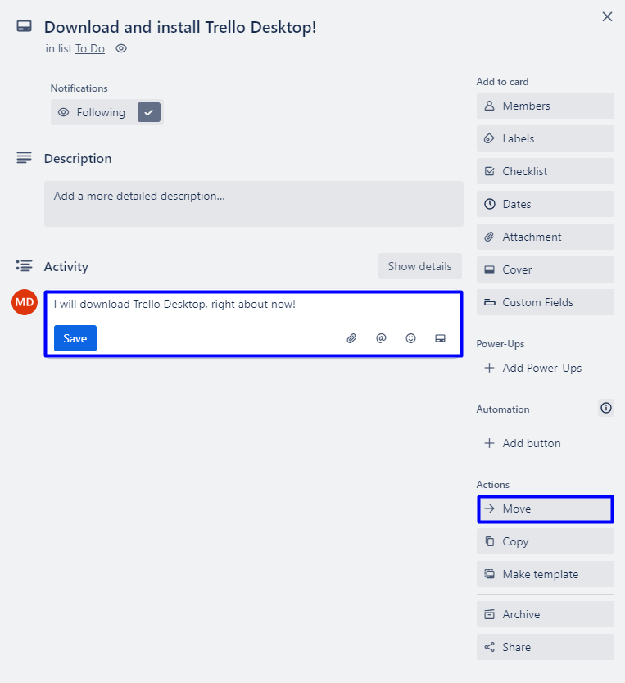

## Trello Desktop

**1.** **Navigate** to [**https://trello.com/platforms**](https://trello.com/platforms). For the purpose of this tutorial, we are installing Trello on Windows, so **click on the "Get it from Microsoft Button".**

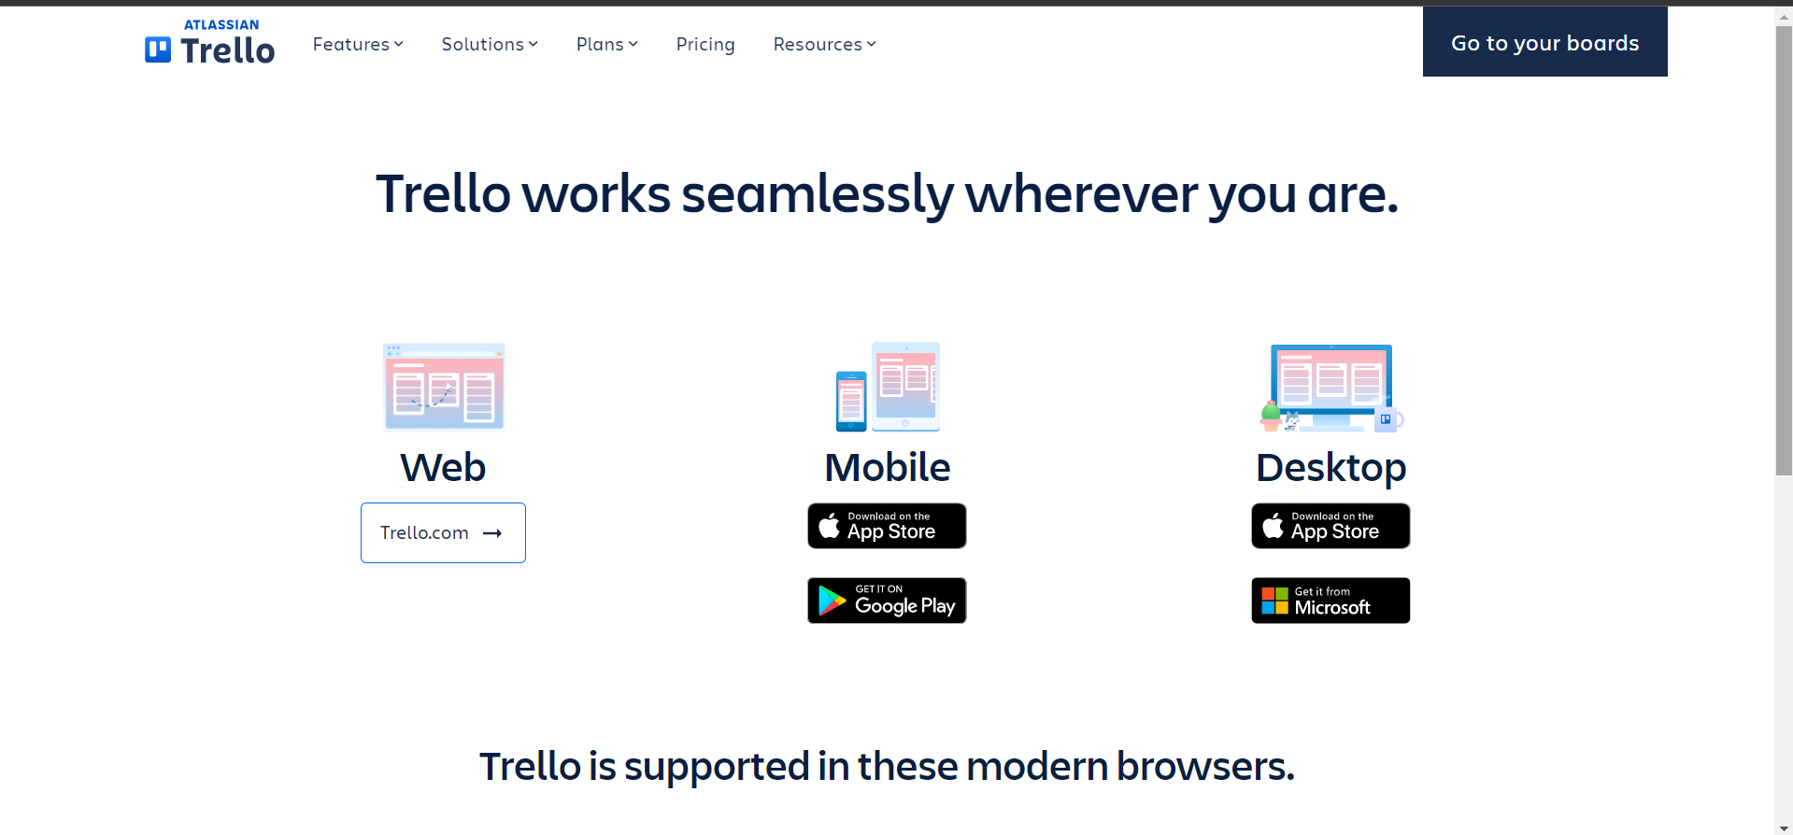

**2.** You'll be redirected to Trello's page on Microsoft store, so click **"Get in Store app".**

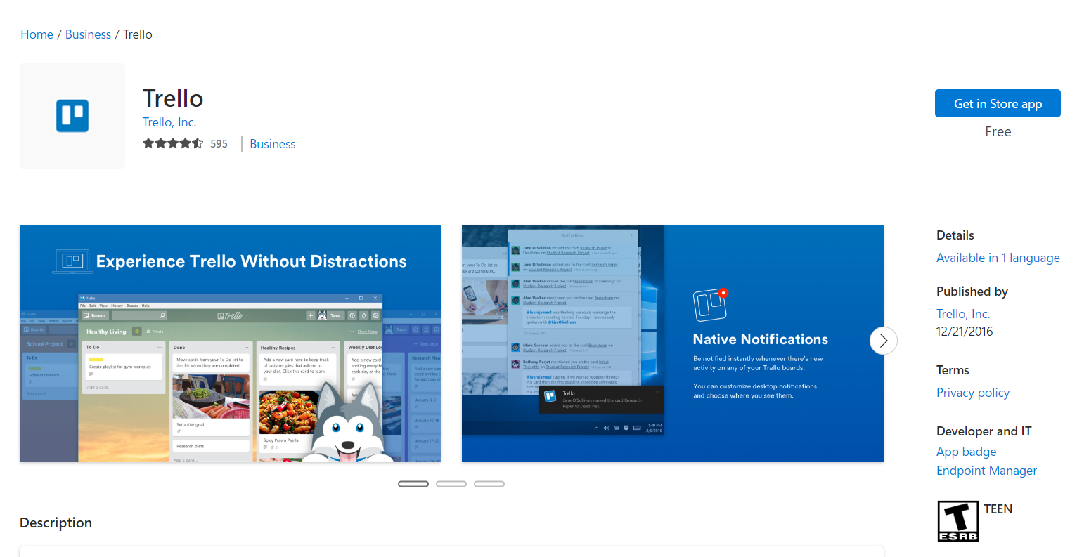

**3.** On the following pop-up window, click "Get" and when download completes 🡪 "Open".

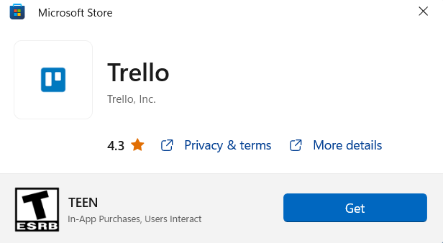 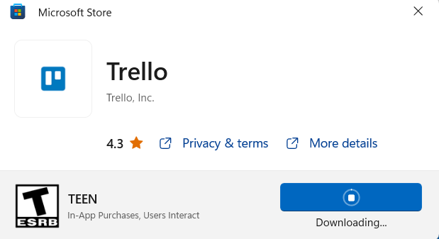

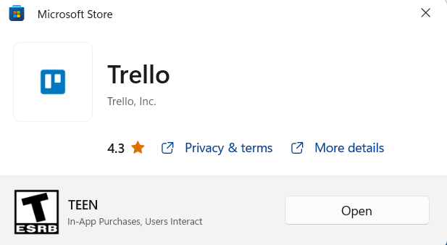

**4.** This is how the first screen looks like. **Hit "Continue".**

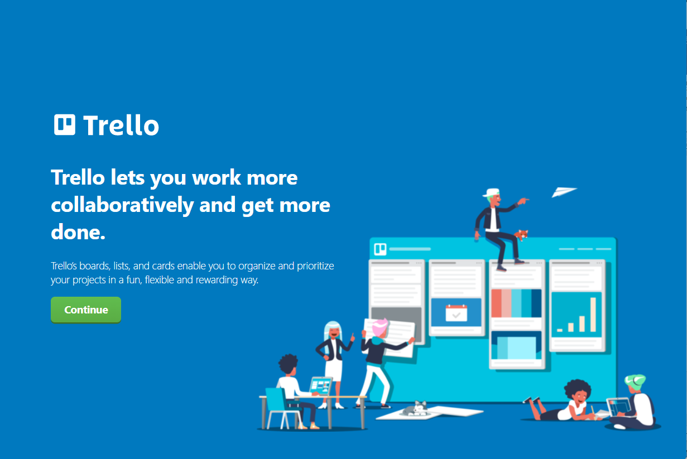

**5.** Since you already have an account, created via Trello Web App **"Log in" with your credentials.**

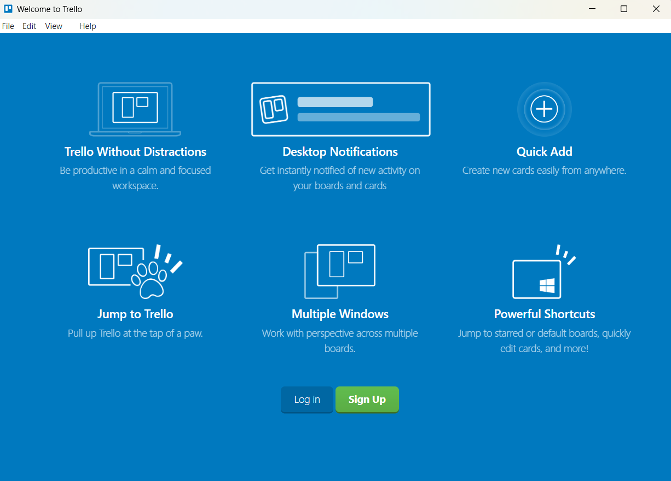

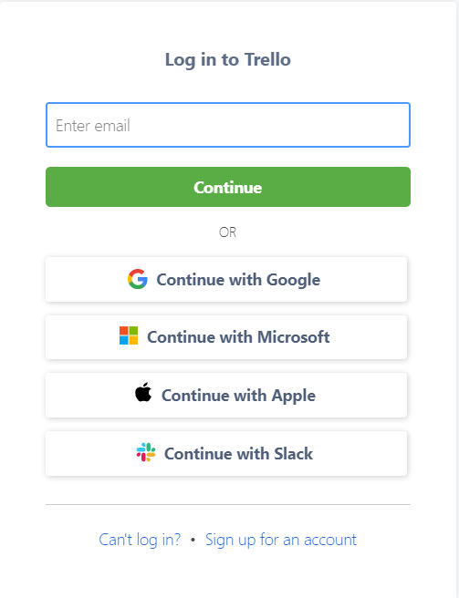

**6.** As you can see, your project is here, as well as its board. Also, you may notice, that the **user interface is the same** as in the Web app.

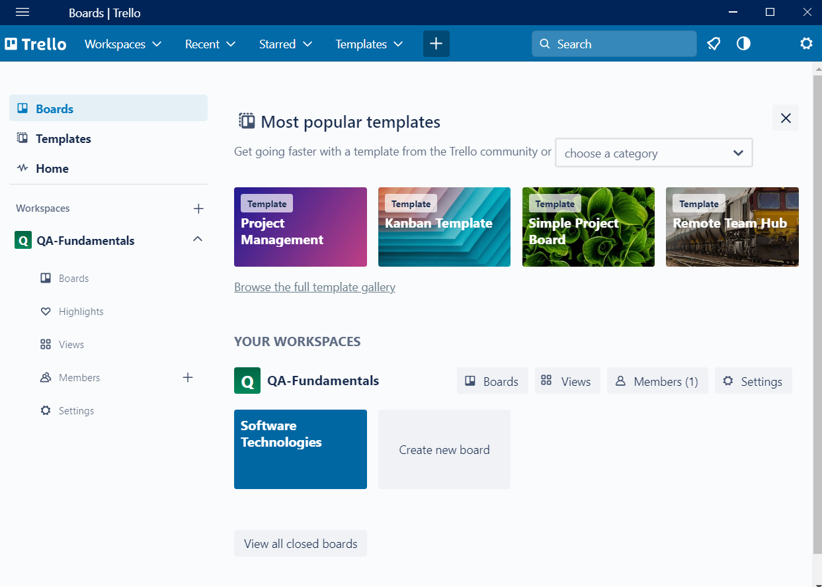

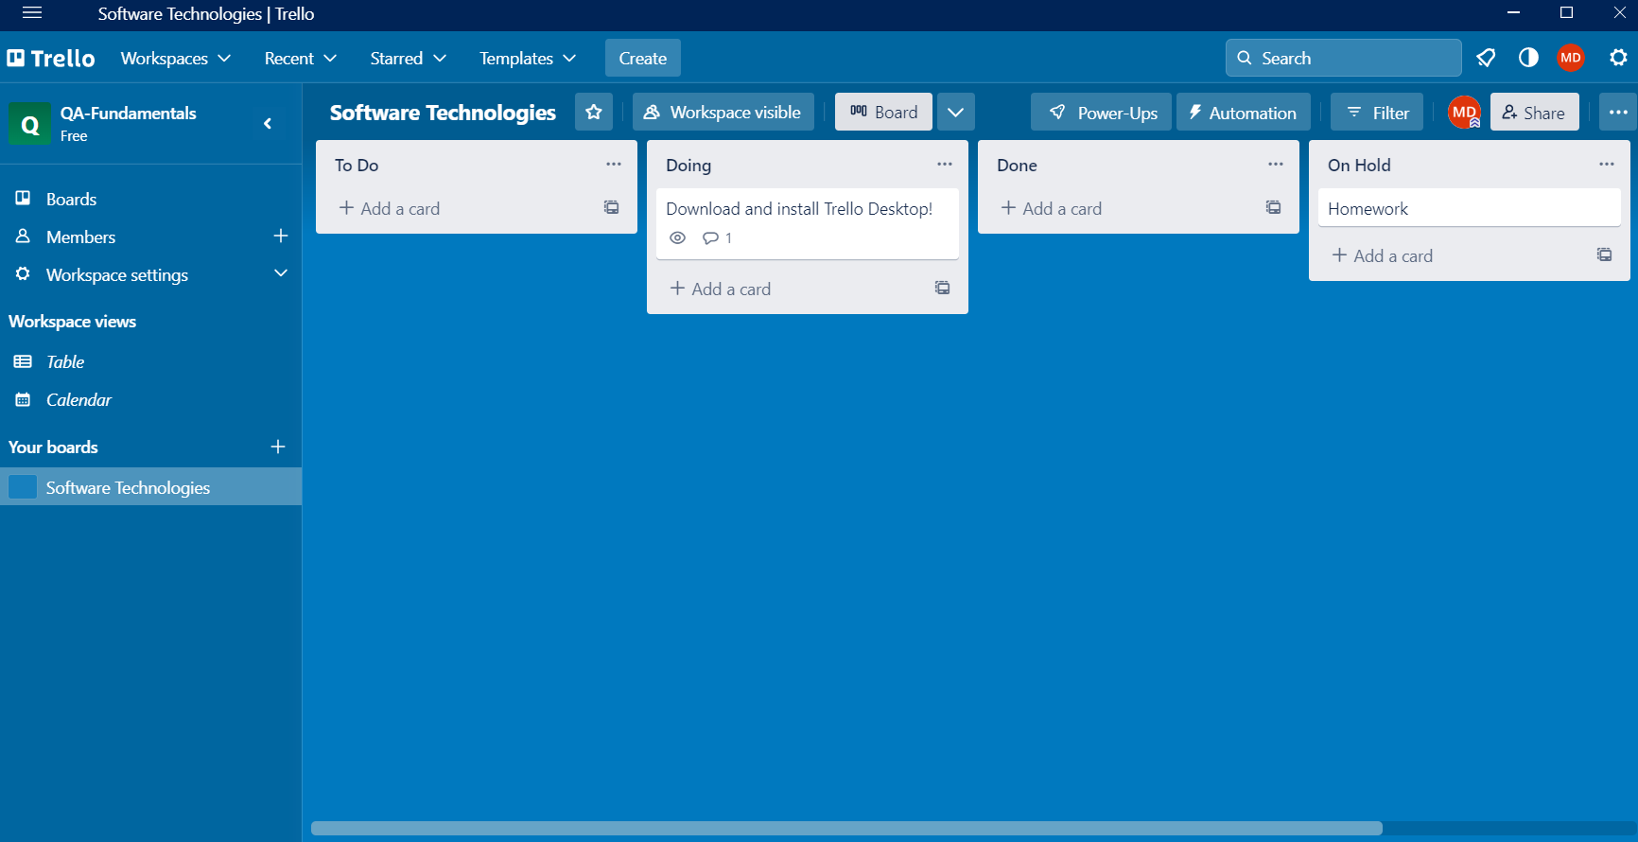

**7.** Now move the **"Download and install Trello Desktop!"** card from **"Doing" to "Done".** And then **sent it to Archive.** The option to "Delete" card appears, only after a card is archived. If a card is deleted, it cannot be restored, while if it's archived – it can. To unarchive a Trello card, head to the board that used to host the card and click on " Menu" on the top right side of the board. Next, click "More" and navigate to "Archived Items". There you will see every card you've archived on that board. To restore a card, simply click "Send to board".

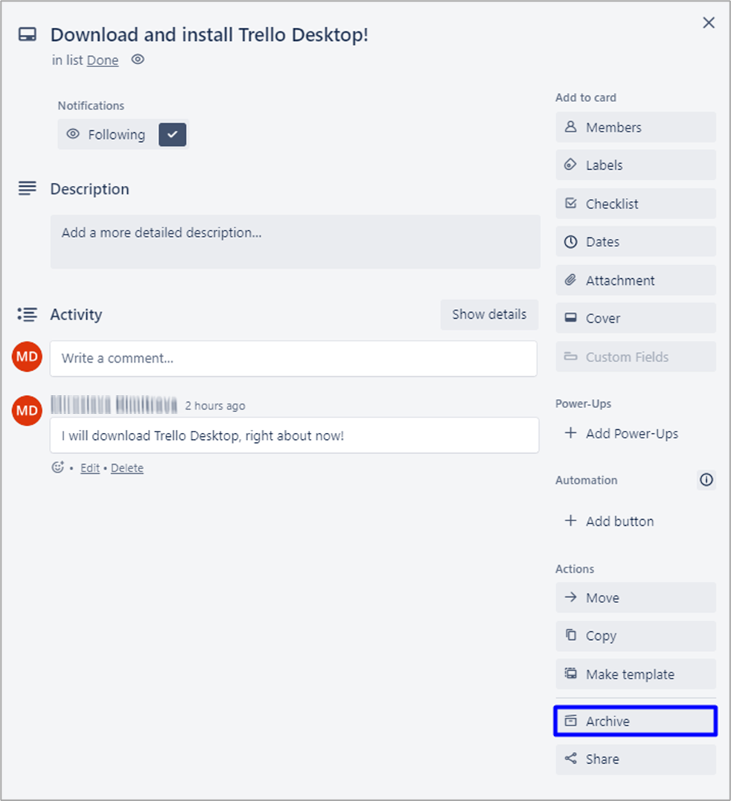

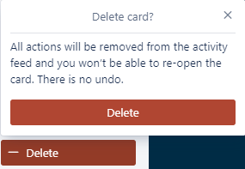

**8.** Now create a new card in board "To Do", name it **"Download Trello Mobile".**

**9.** Move it to **"Doing".**

## Trello Mobile

**1.** For the purpose of this tutorial, we are installing Trello on Android, so **open Google Play, search for "Trello", install it, and log in with your existing account.**

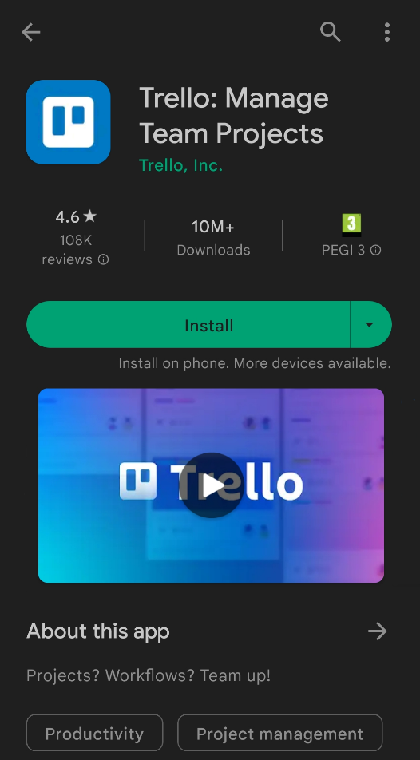 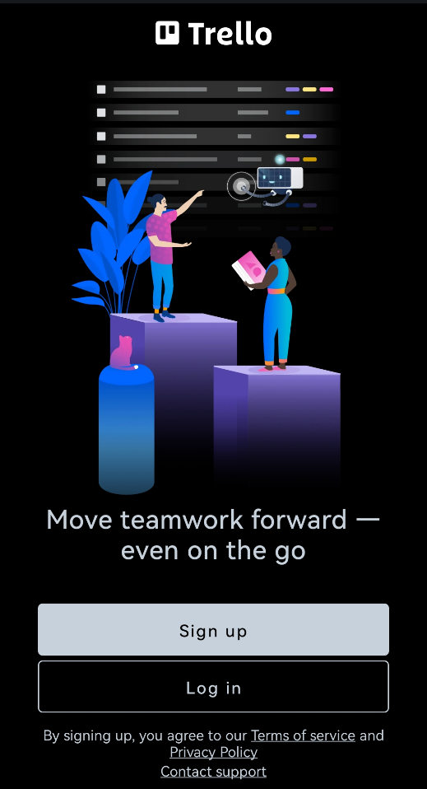

**2.** As you can see your project "QA-Fundamentals" with its board "Software Technologies" is present.

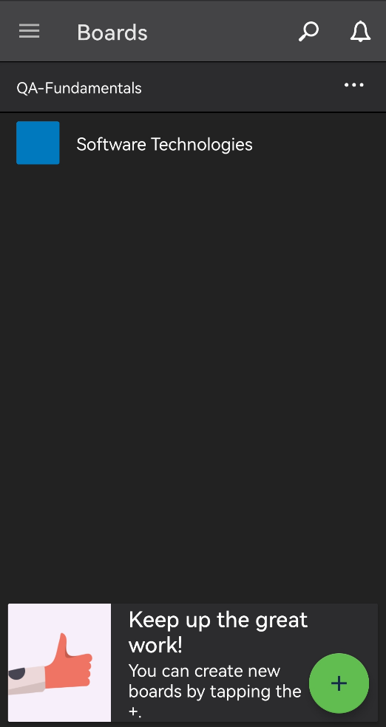 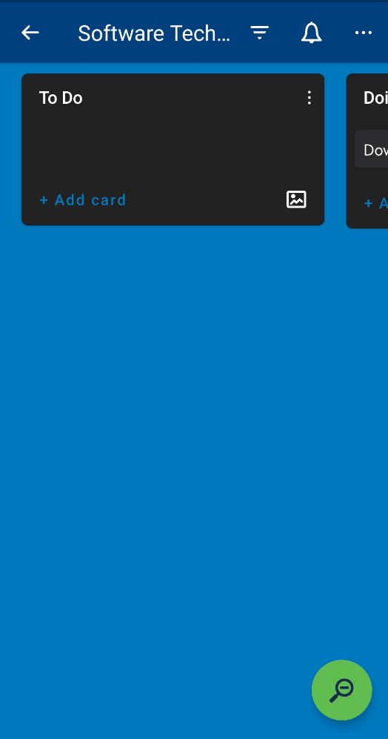

**3**. Navigate to the "Doing" list and **move the "Download Trello Mobile" card** in the "Done" list.

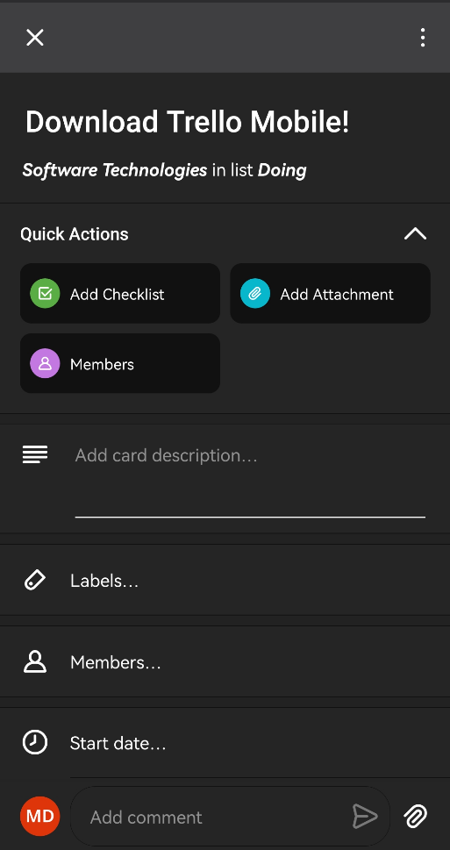 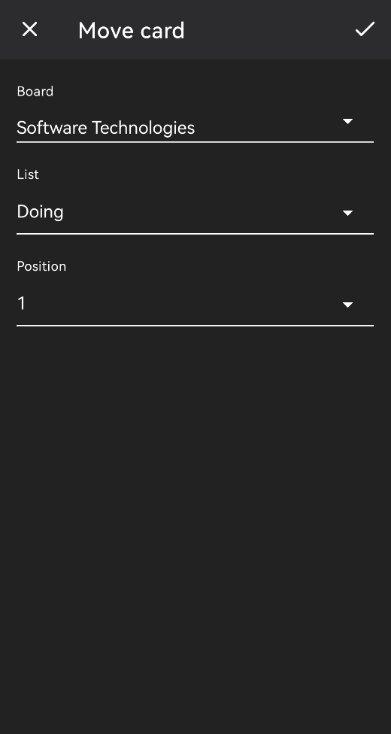 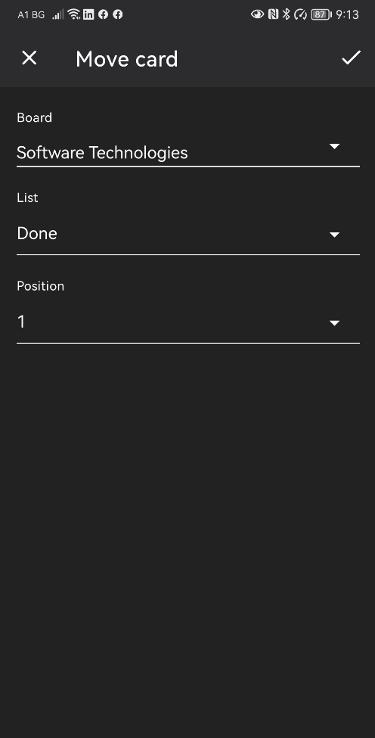

4. Now in your "To Do" list **create a new card**, named "Create new board!", head back to the main page of your workspace, where we will create the new board. Click on the green "plus" button.

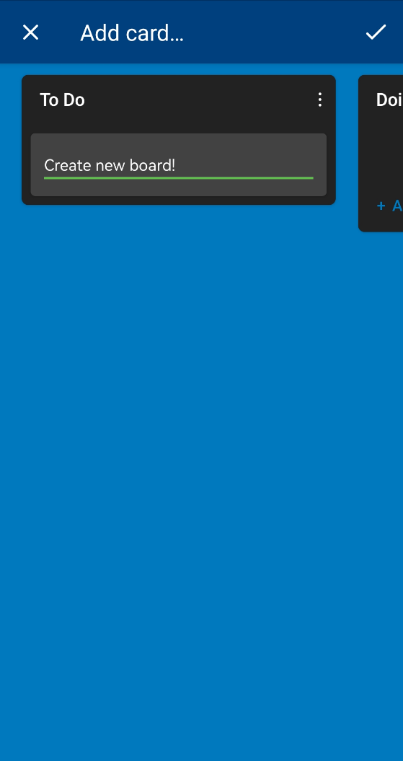 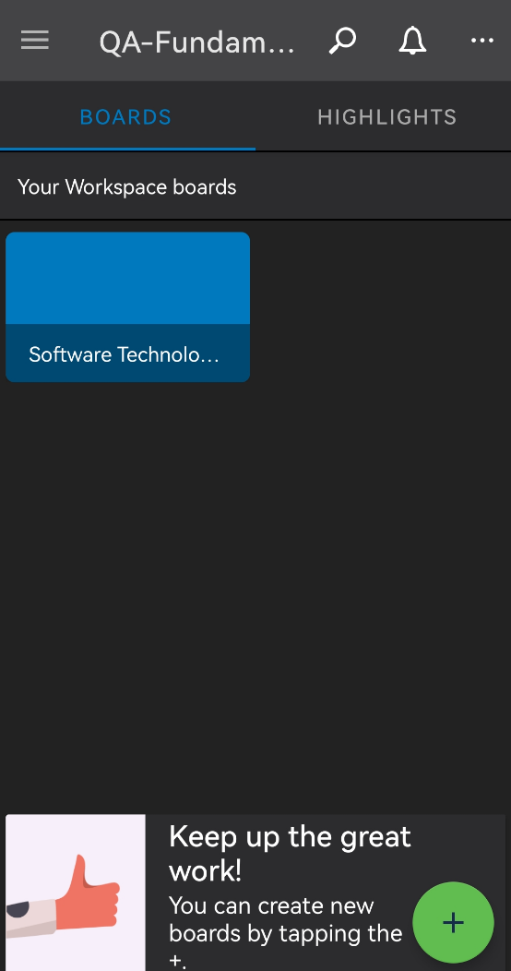

**5.** Let's **browse the templates** to see what board to create.

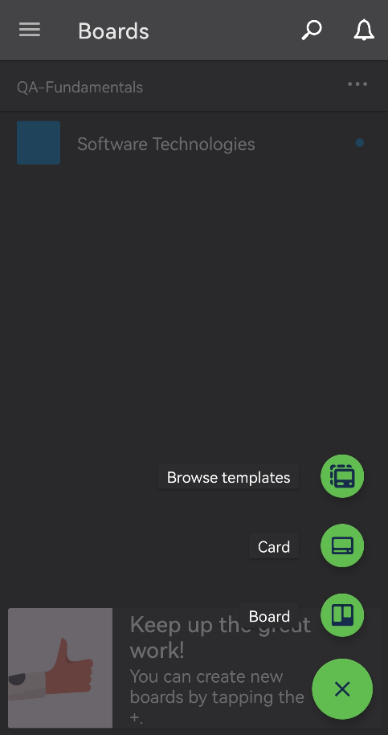 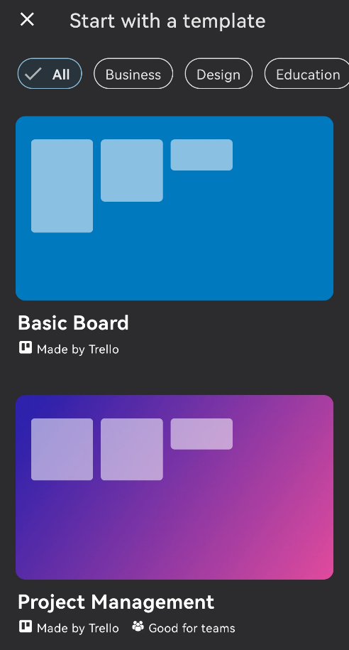 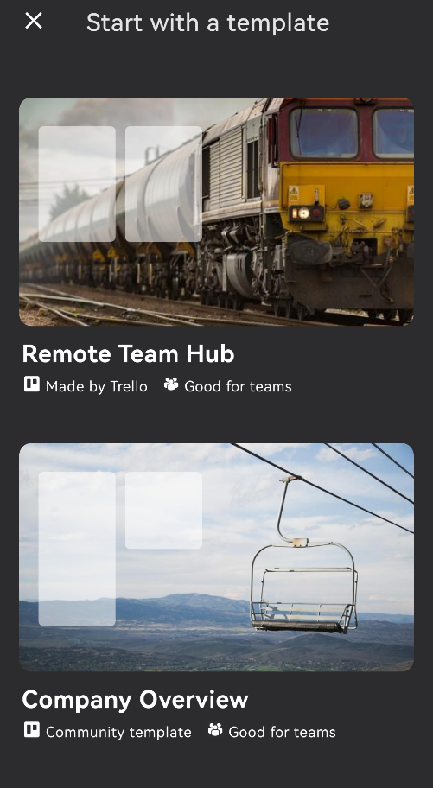

**6.** As you can see there's number of possibilities, but for the purpose of this tutorial, we will **create a Kanban Board**.

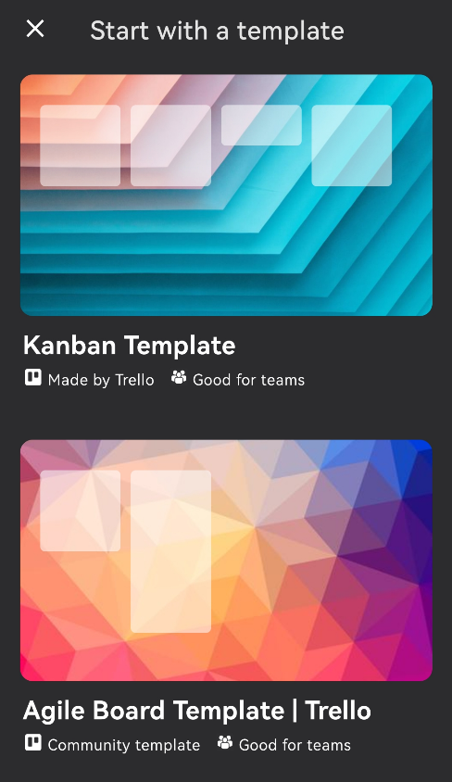 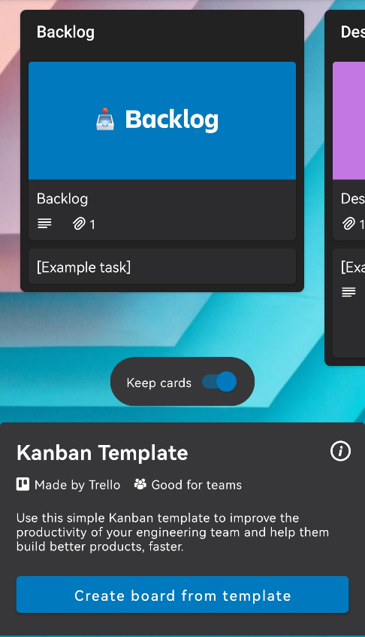 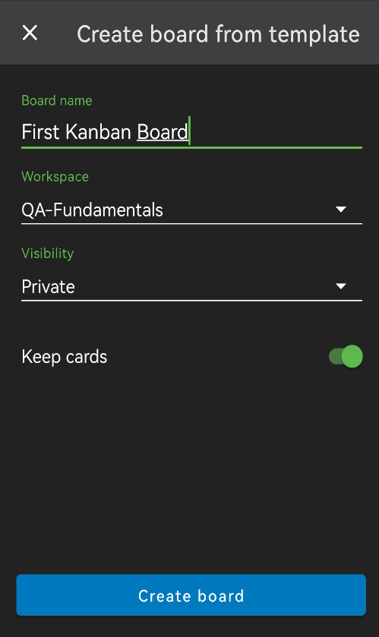

**7.** So now that we've created our first Kanban board, we suggest you move back to Trello Web or Desktop App, because it is easier to observe more content on a desktop screen.

## * Kanban Board

Trello's Kanban board is a powerful tool for managing projects and workflows, allowing teams to collaborate more effectively and stay on top of their work.

1. As you can see, except for the "To Do", "Doing" and "Done" lists, there are "Backlog", "Design", "Code Review", "Testing". As a QA engineer, it is likely to use Kanban boards on a daily basis. You can read more about what Kanban is [here](https://www.atlassian.com/agile/kanban).

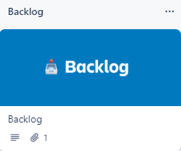 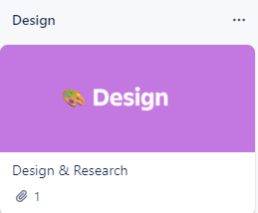 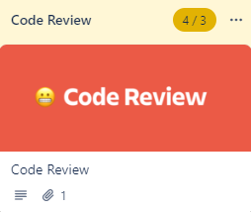 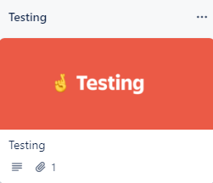

2. You can continue to **explore** the capabilities of **Trello** by following this official [tutorial](https://trello.com/guide/trello-101).